Suggested Weekly Learning Activities for Teachers
Subject Area: | Numeracy 6-8
Big Idea: | Build a Playground  Shape and Space: Area, Perimeter  Number sense - multiplication, addition, 15% tax*
Plan/Instructions: | Several stores are sold out of backyard playground sets and playgrounds in the province are closed! The great news is, you can design and build your own!  Your mission: To design a backyard playground and calculate the total cost for the supplies.
Materials needed: | Paper, ruler, pencil, eraser, material list (attached), calculator
Source: | GNB rules of social distancing
Additional Resources: | https://www.homedepot.ca/en/home.html
Opportunities for Stretch: | Create a community playground but you must stick to a budget. (ex. less than $10 000)

Step 1 - Design your ideal playground using the following guidelines.
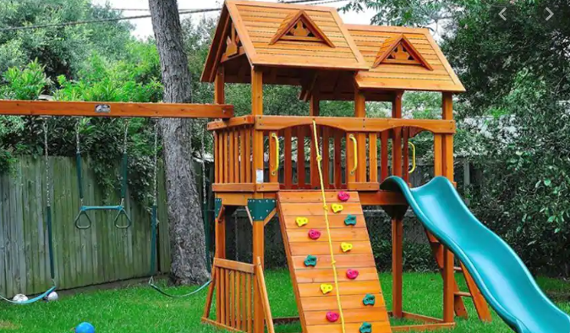
It must include:
- at least one slide
- at least one climbing piece
- at least 2 swings
- more than one level
- an interactive accessory

Step 2 - Create a sketch of your playground.

Step 3 - Using the material list below, decide what you need to buy to build your playground.

Step 4 – Grade 6 – It’s tax-free day! Calculate the cost of materials only.
*Grade 7 and 8 – You missed out on the sale. Calculate the cost of materials including 15% sales tax.

Materials: (more items online at Home Depot)

Slides:
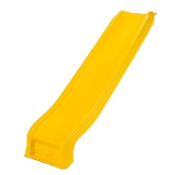  48’ Deck  $129 | 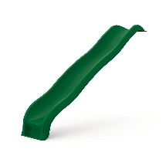  60” Deck  $571 | 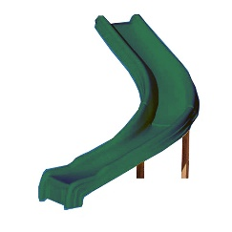  60’’ Deck  $294 | 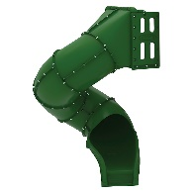  60’’ Deck  $998

Swings:

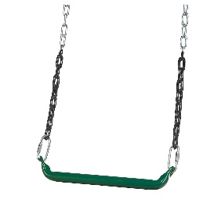  Trapeze Bar  $49.49 | 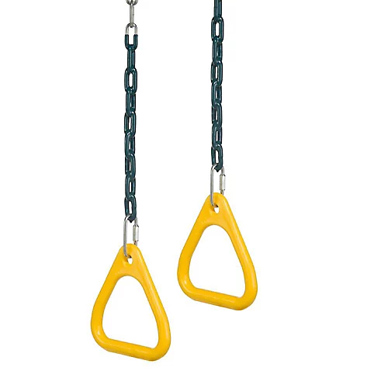  Gym Rings  $28.02 | 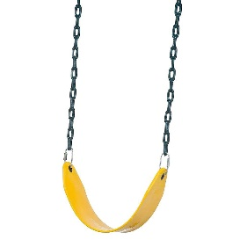  Swing Set  $34.99 | 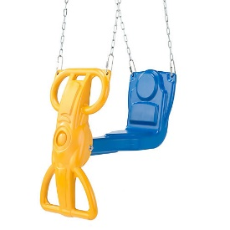  Glider Swing  $99.00

Climbing:

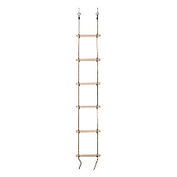  Rope Ladder  $76.99 | 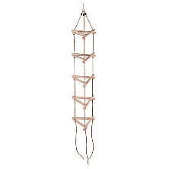  Triangle Rope Ladder  $109 | 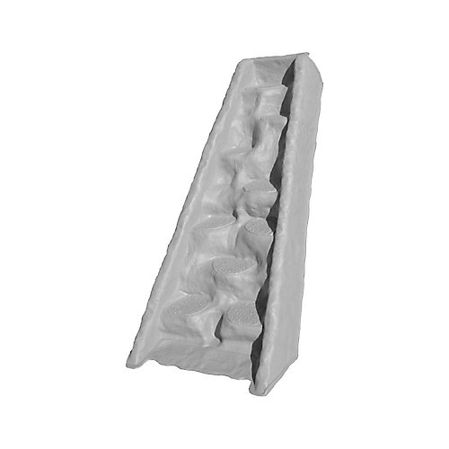  Climbing Wall  $479 | 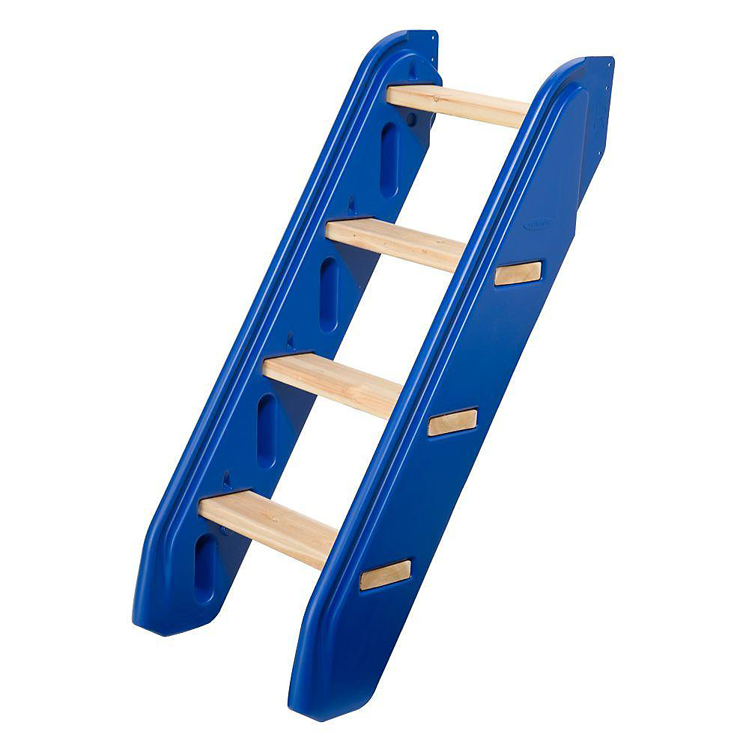  Steps  $294
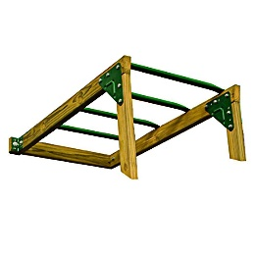  Climbing bars  $87.98 | 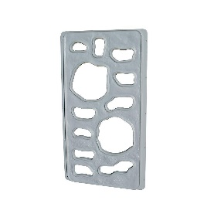  Vertical Climber  $155 | 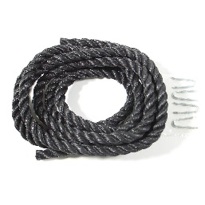  Clibing Rope  $25.86 | 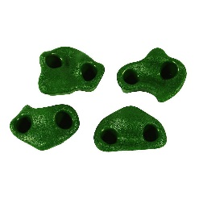  Climbing Rocks (set of 4)  $35.56
Other Accessories:

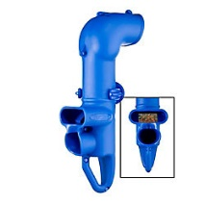  Speak and Spy  $59.27 | 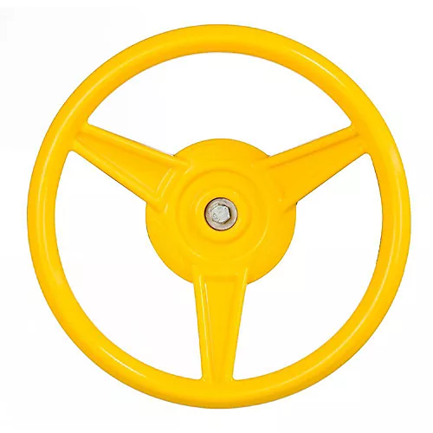  Steering Wheel  $28.02 | 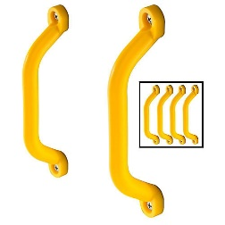  Handles (set of 4)  $43.10 | 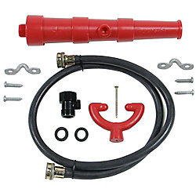  Water Cannon  $39.34
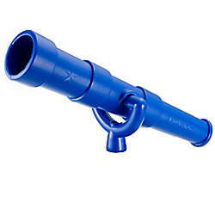  Telescope  $34.28 | 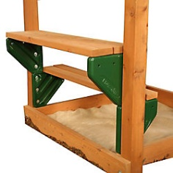  Picnic Table Brackets  $62.72 (set of 2) | 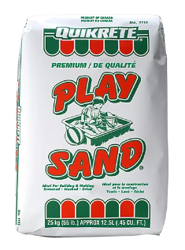  $6.98 for 30kg bag  (See chart below) | 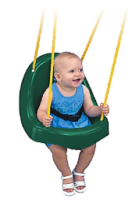  Toddler Swing  49.99

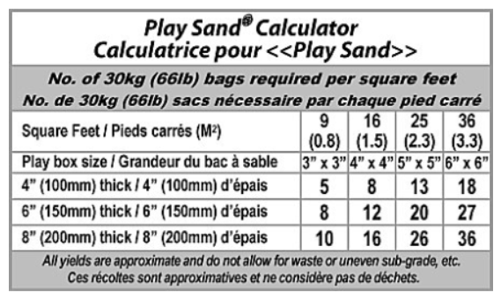

Building Materials:

Deck Boards | 5/4 x 6’’ x 8 feet | $6.85
 | 5/4 x 6’’ x 10 feet | $8.55
 | 5/4 x 6’’ x 12 feet | $10.25
 | 5/4 x 6’’ x 16 feet | $13.70

Posts | 4 x 4 x 8 | $12.48
 | 4 x 4 x 10 | $15.42
 | 4 x 4 x 12 | $18.84

2 x 4’s | 2 x 4 x 8 | $6.22
 | 2 x 4 x 10 | $7.90
 | 2 x 4 x 12 | $9.14
2 x 6’s | 2 x 6 x 8
 | 2 x 6 x 10
 | 2 x 6 x 12

Screws | 3” Deck Screws (1000) | $46.00
 | 3” Deck Screws (250) | $27.00

Enrichment:

- Find a playground set online (Home Depot, Toys R Us, Kent, Canadian Tire, Walmart, etc.) and calculate the cost to build it buying the materials vs buying the whole set. Which is cheaper?

- You are hired by the town/city to design a large community playground to celebrate the lifting of social distancing rules. You can be as creative as you wish and your playground can include dry and wet activities. Create a plan and a budget to present to the town/city council. They have asked you to try to stay within $10 000.

